**Name:** Hyungu Kim

**Date:** NOV 24, 2022

**Course:** IT FDN 130 A Au 22: Foundations of Databases & SQL Programming

**Assignment 6 – Views, Functions, and Stored Procedures**

Introduction

SQL view is used when we have a long and complex query. Doing this way, it saves time on retyping and running the query. We can store it in a view and simply run the “select” statement on that view. There are differences between Views, Functions, and Stored Procedures. A View simply represents a virtual table. We can join multiple tables in a view and use the “view” to present the data as if the data were coming from a single table. A function produces information. Functions return values. This can be seen as like “view”. However, they are different since a view returns a specific pre-defined statements as exactly one result set, while a function returns a single value or a single result set. A Stored Procedure is precompiled database query that improves the security, efficiency and usability of database applications.

Topic

What we have focused on this assignment was the use of “view” statement. Utilizing this statement allows users to access into more specific set of data per their requests. The view function allows the users to simplify the vast information in the database into a viewing table which provide much detailed information for certain categories.

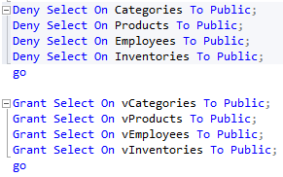As you can see from the figure one on the left, the “Deny & Grant” statement seemed very practical to me since this function allows only people with granted access to manipulate the data. When data or codes are manipulated, it is hard to be fixed back to the regular stage. By grating access to only certain people will enable to prevent data loss by random strangers.

Inner join function was used very often throughout this assignment as well. They allow the users to combine multiple tables so that they can have the simple sets of data in one table. 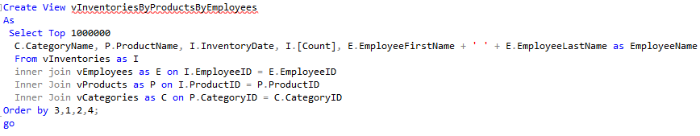

***Figure 1. Grant & Deny***

***Figure 2. Inner Join***

This assignment has provided me a good idea of how real life SQL coding jobs would be. They will use this “view” function to draw requested data from such big database. “Inner Join” and “Where” functions were very often used to narrow down the result of the “view” statement.

Summary

“View” statement certainly enables the users more efficient way of looking for specific data in a big set of data. At the same time, granting and denying certain pool of users, it helps companies to prevent data loss or manipulations which would significantly hurt one’s company. “inner Join” function seemed such a prevalent function in SQL coding since it allows users to combine multiple tables, which is very crucial to find specific information in a combined lists of already created tables.